LAB TASK: 07
Task 1:
Write a function that takes two numbers and returns their product.

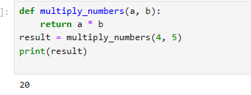

Task 2:

Write a function that checks whether a number is even or odd.

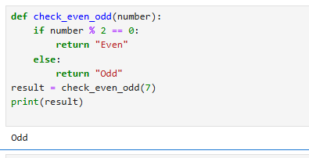

Task 3:

Write a function that takes a name and age and prints a greeting.

